# Azure Cloud

1. **Important Notes:**

--------------------------------------------------------------------------------------------------------------

Network Interface – All the data into VM passes via Network interface. Network Interface attached with VM like Desk.

--------------------------------------------------------------------------------------------------------------

App Service Plan (in Web App) – is responsible for building a computer infrastructure which is required for running your web application. And creation of App service plan depends on what runtime stack & operating system you have selected -> It would be different for Asp.Net core and different for php and different for ruby.

We can create multiple Web App under same app service plan but runtime stack and operating system should be same -> If you choose different runtime stack (like Java or ruby) -> then app service plan will be different.

--------------------------------------------------------------------------------------------------------------

If you deploy your application into Web App -> You can store your connection string into Wep App instead of appsetting.json file.

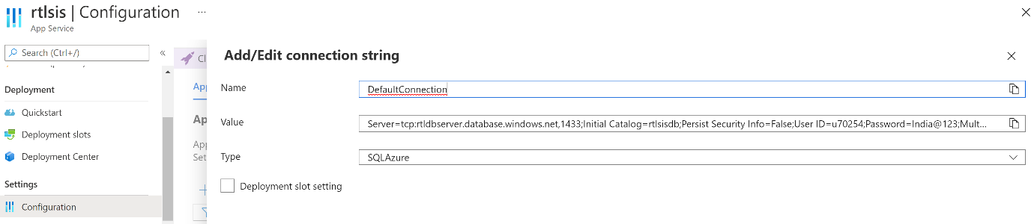

--------------------------------------------------------------------------------------------------------------

Azure Web App can do Continuous Deployment -> We can setup continuous deployment feature by selecting Deployment Centre -> choose your centralized repository -> as soon as code available into repo -> it automatically deploys into WebApp

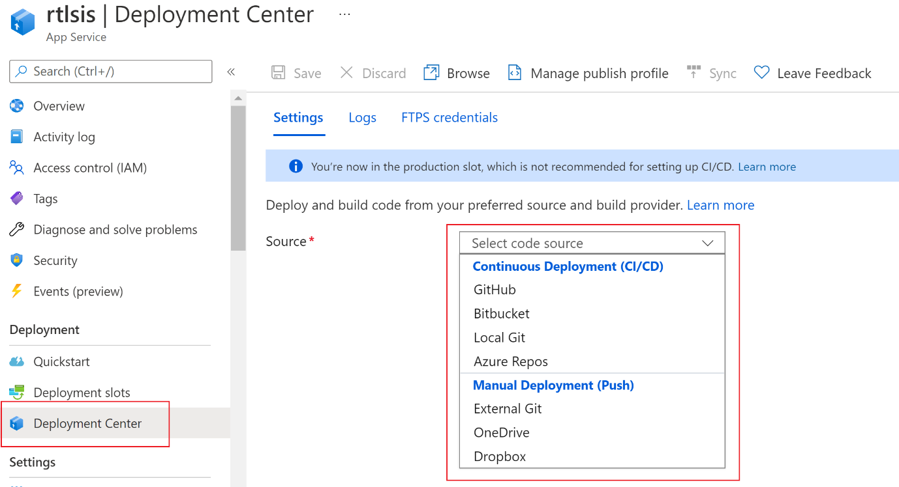

--------------------------------------------------------------------------------------------------------------

Enable secure connection to web app: (https)

Go to TLS/SSL settings -> create App Service Managed Certificate ->

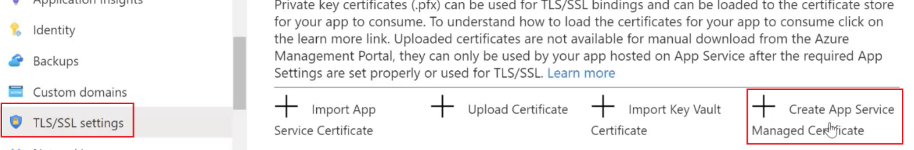

Once done -> Then go to bindings -> Add TLS/SSL Binding

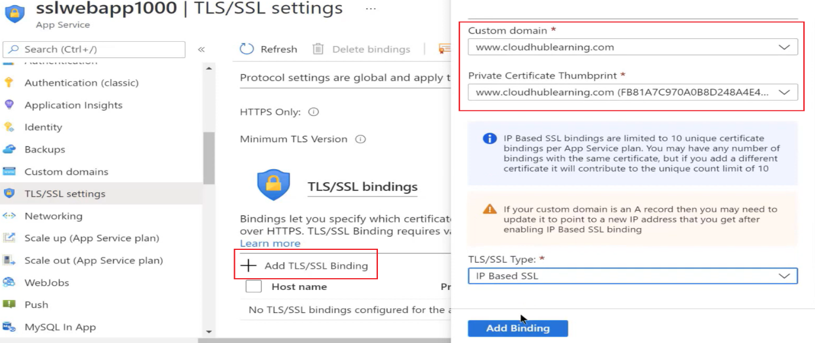

--------------------------------------------------------------------------------------------------------------

Enable Logging -> Go to your webapp -> scroll down and click “App Server Logs” -> you will get many features for logging.

To view the log -> go to “Log Stream” -> and see the real time streaming.

--------------------------------------------------------------------------------------------------------------

Azure App Configuration -> If you want to store your app configuration in central place for all different application -> then create a separate resource -> “Azure App Configuration”

Once resource Created -> go to configuration explorer -> create a new key-value

Add package of App Configuration into your visual studio project and Define configuration.

--------------------------------------------------------------------------------------------------------------

CORS: Cross-Origin Resource Sharing (CORS) is an HTTP feature that enables a web application running under one domain to access resources in another domain

Example: You develop and Web application, and one Web API -> You deploy these two applications on Azure in different domain. -> Now when Web Application was to access API -> it throws error (Reason: CORS provides a secure way to allow the origin domain to call APIs in another domain.

Solution: Go to your API web App -> select CORS -> Provide the URL of your web application

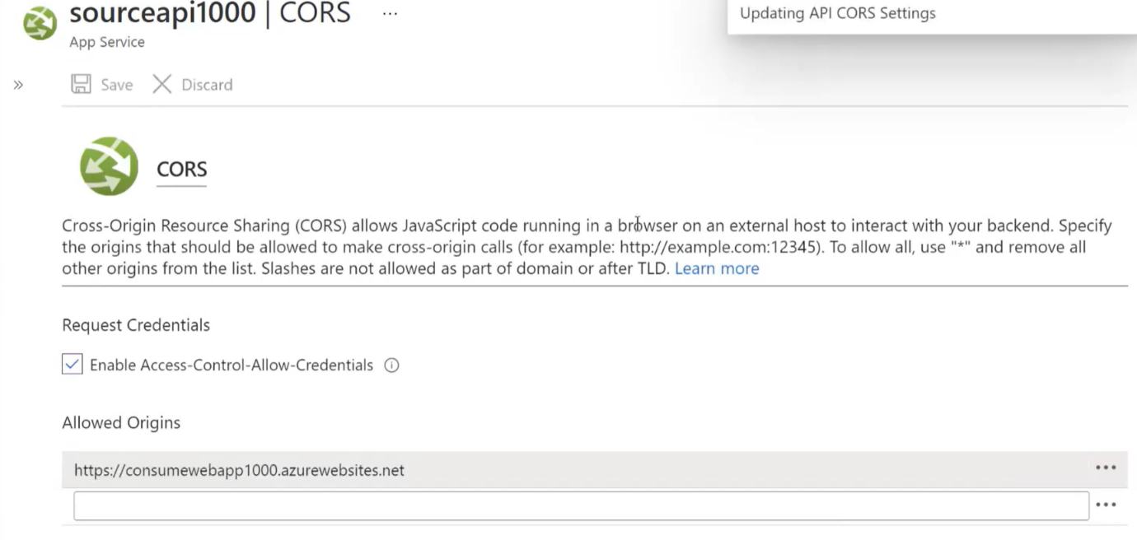

--------------------------------------------------------------------------------------------------------------

1. **When you go and deploy application on VM?**

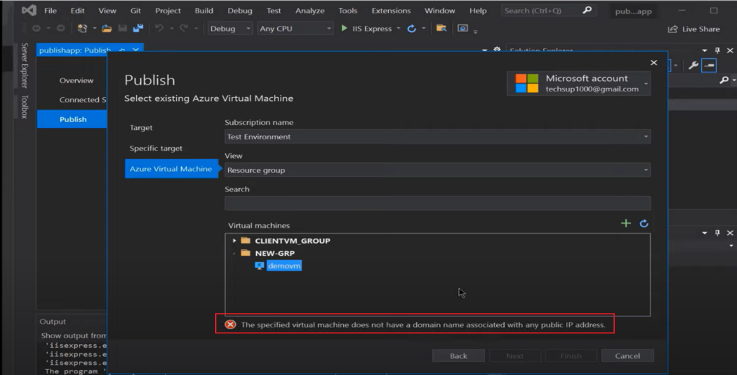

To fix this issue ->

* Go to your VM -> Click Public IP -> make IP as static -> define DNS name label

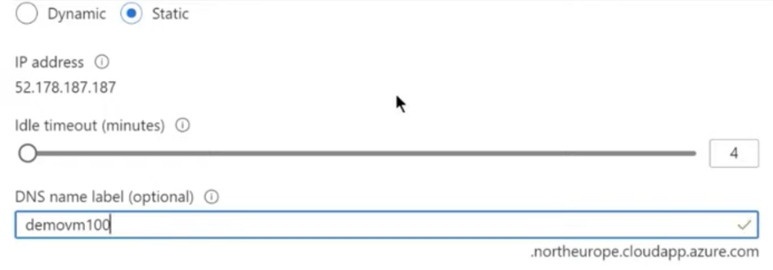

* RDP virtual machine and -> add the role of management service on the VM.

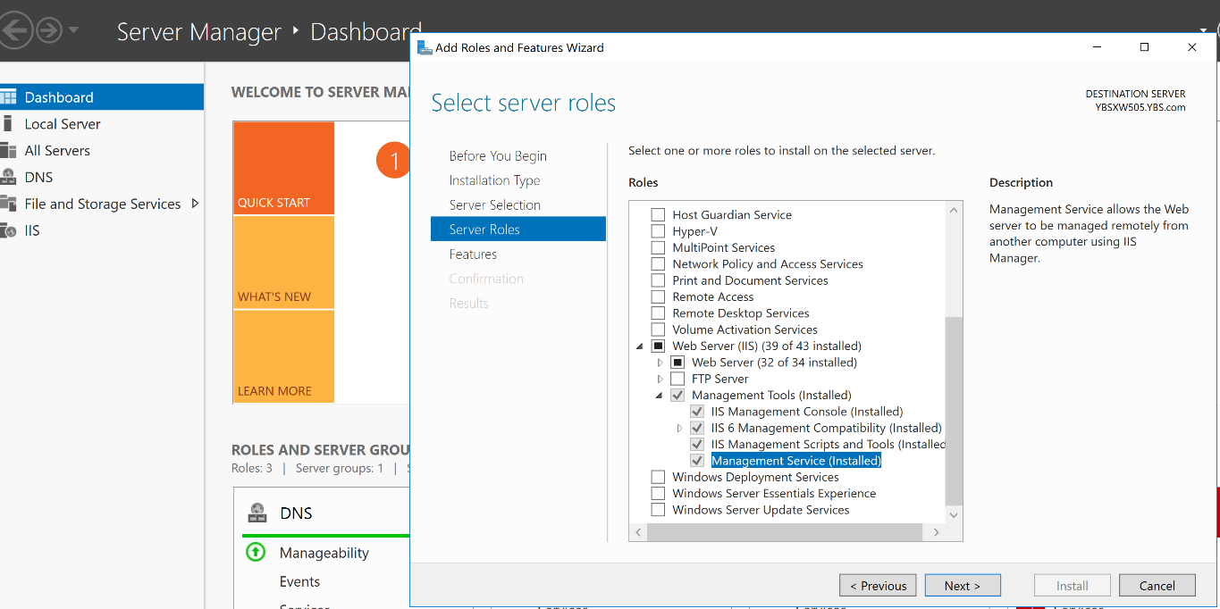

* Check the configuration of management service on IIS -> Enable remote connection -> Apply and then start this service. -> This will allow your Visual Studio to connect on VM

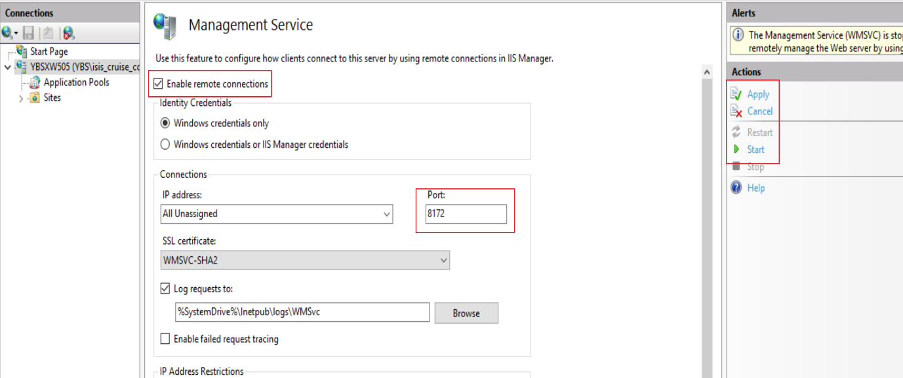

* Since above manage service running on port 8172. -> go to your Virtual Network -> Add inbound rule for 8172
* Install the .Net core hosting bundle -> This will allow .Net core web application to be hosted on IIS.
* Install the Web Deploy V3.6 tool -> This allow to install & publish application on IIS from visual studio
* Now before going to publish the application -> assign VM password to visual studio to connect on VM -> click on edit

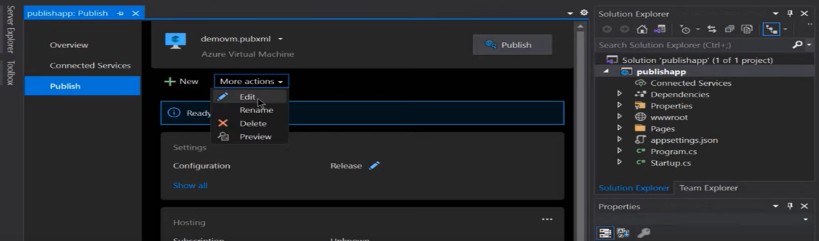

* Now before going to publish the application -> assign VM password to visual studio to connect on VM -> click on edit -> in connection tab provide VM password -> and validate

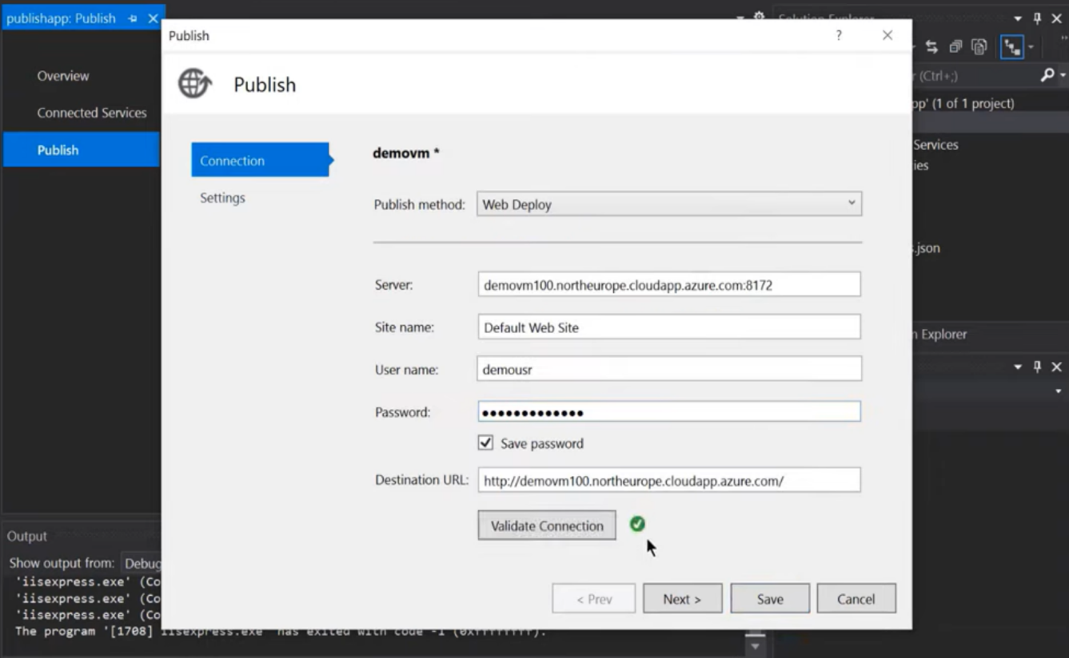

* Now publish the application on VM.

1. **What is Web App?**

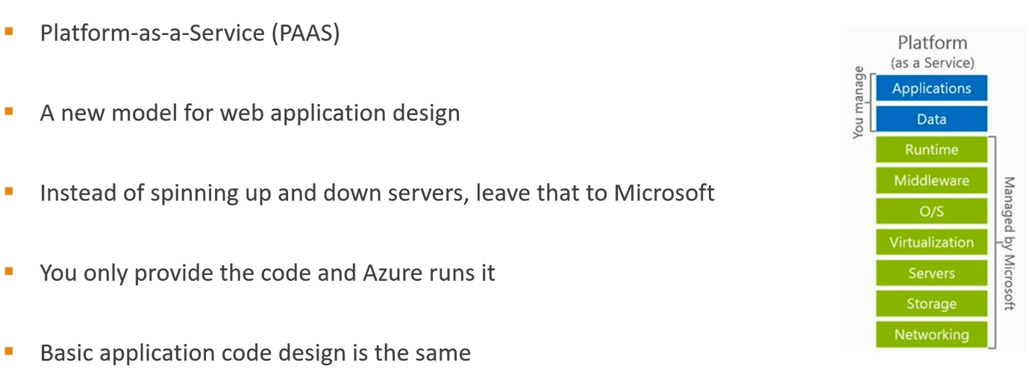

Even though in above, we only responsible for application and data, and rest infrastructure will be managed by Microsoft -> Still we must develop a monolithic application

* We have solution that might contains multiple projects -> these projects have sub-folders -> these sub-folders have dozens of cs files
* And we need to scale it -> we make more copies of the application.

1. **ARM template?**

Automate deploying resources with Azure Resource Manager templates in a single, coordinated operation

Search for template deployment -> Select the template and deploy

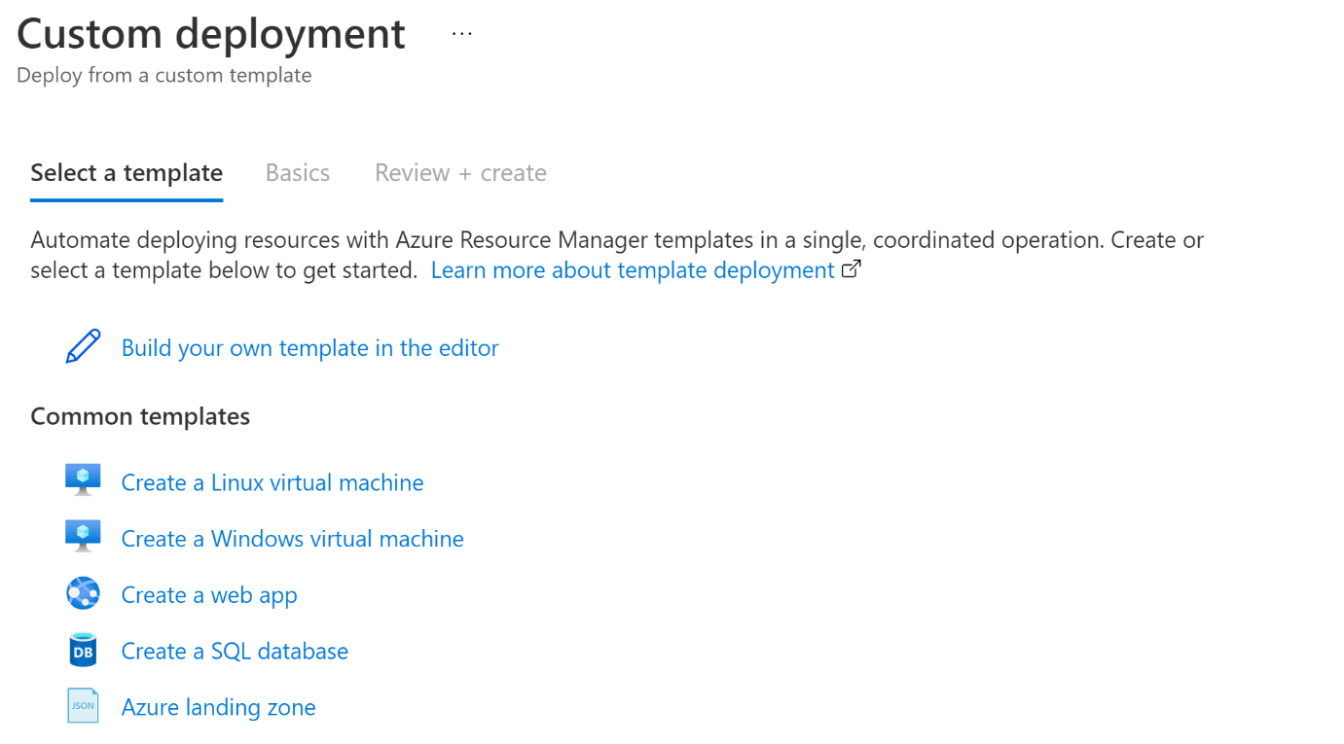

1. **What is serverless?**

Serverless doesn’t mean that something has no server -> It’s the services not server



Microsoft provides these serveries and we just consuming these services -> its not in your server

|  |  |
| --- | --- |
| * Azure Function * Azure Logic Apps * Azure Bots * Machine Learning | These all are integrated with Azure Storage and Azure Database via API |

Serverless model is Event Driven -> Don’t have application that are always running, “no concept of continuous running”.

Require an event for something to happen, even a timer. -> Any trigger that can start and stop the application.

1. **Azure Function App:**
   1. **Serverless Use Case: ETL**

ETL is the process which integrates different systems with data transformation.

Serverless architecture makes the job easier -> A trigger can fire when data available for transformation and reduce the time, and auto scale when with increase the data transfer rate.

**Let’s Take an Example:**

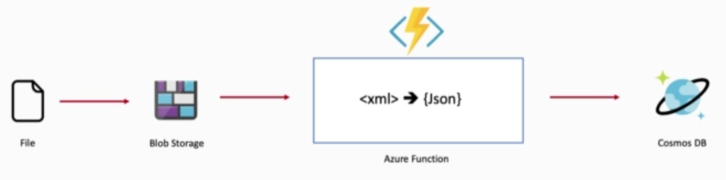

User Store the file (xml) into Blob storage -> as soon as file loaded, it needs to convert into JSON and then store into database.

We will setup Event Grid, which will trigger new event when new item added into Blob storage -> it send http request to function to process the request ( Convert xml data into JSON) -> once its done result will store into Cosmos DB.

* 1. **Serverless Use Case: Analysing Image**

Another use case is analysing image and convert it into thumbnail.

* Upload Image resize the thumbnail, call computer vision API to in cognitive services to recognize the content of image & save the metadata into database.
* Notify Admin for image uploaded.

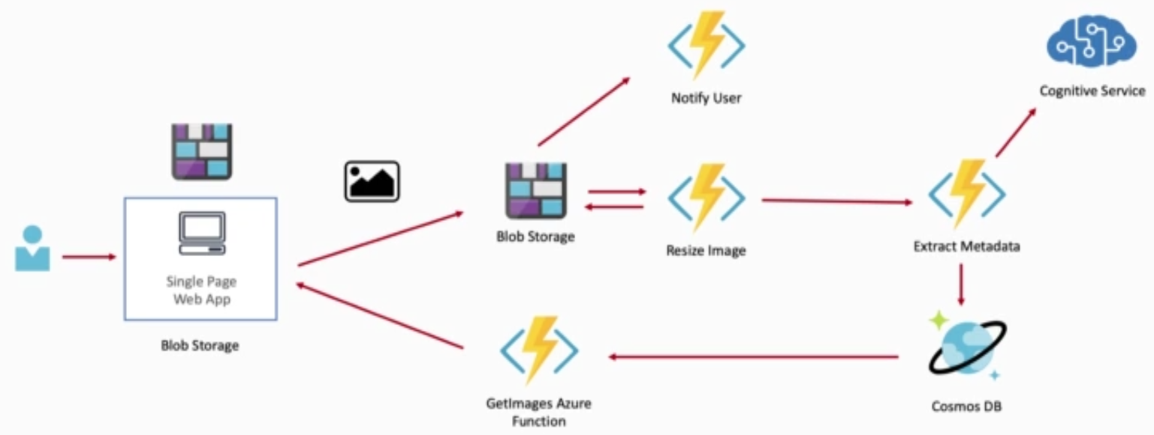

**Solution:**

* User upload image -> which store into Blob storage
* As soon as image uploaded -> Event Grid trigger the Function App -> Function will resize image into Thumbnail -> The Thumbnail store back into the blob storage
* Image then forward to another function which usage the cognitive services
* Finally, metadata stored into cosmos DB.
* Another function will fetch the image from database and return it back to application.
  1. **Function Trigger:**

Every Azure function must have exact one trigger. i.e

* HttpTrigger
* Timetrigger
* BlobTrigger
* QueueTrigger
* Event grid trigger
* Application insight trigger

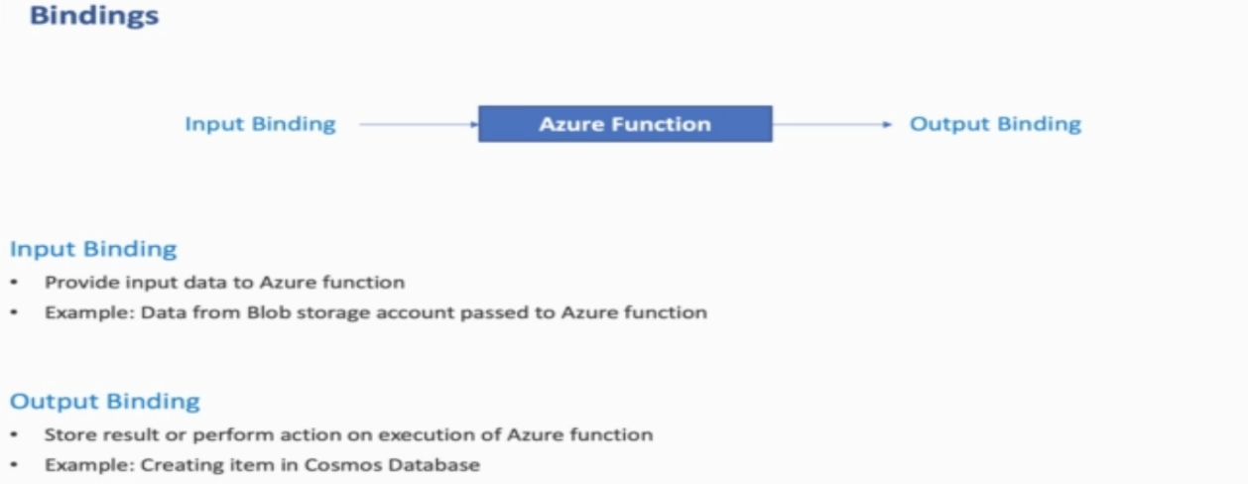

* 1. **What going to build:**

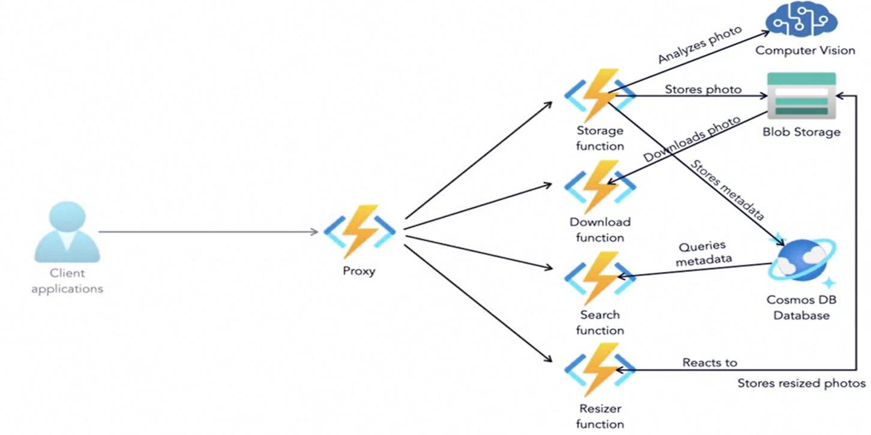

* Storage function will store the phone into Blob storage
* Additionally, Storage function store the photo metadata into CosmosDB
* Using dependency injection technique, we inject computer vision API to validate the image
* Resizer function will responsible to resize the image into appropriate size and store back to another blob location.
* Search function will use to search the photos
* Download function will download the photo
* Proxy function to route the client request.
  1. **Function – Trigger and Binding:**
  2. **Trigger**
* Specify how a function can be invoke
* Function only can have one trigger
* Have associated data
  1. **Bindings**
* Allow to connect data to and from a Function
* Function can have multiple input or output binding.



* 1. **Durable Function**
* Generally, functions are stateless -> They triggered and do the job and done, doesn’t maintain the session of output
* But many times, we have to do operation in sequential manner based on previous task done

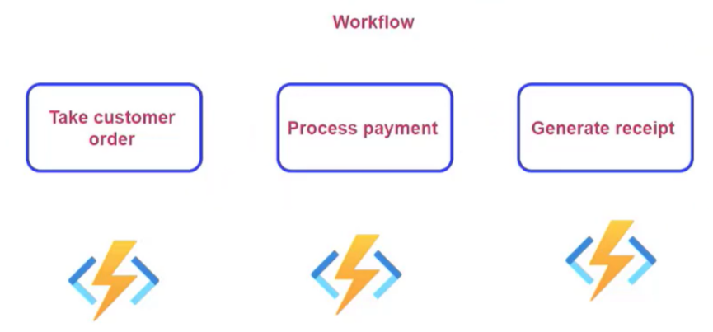

* Sometimes, we have to design workflow in which -> one function triggered many functions to invoke and once they all done -> finally the last function invoke and result output

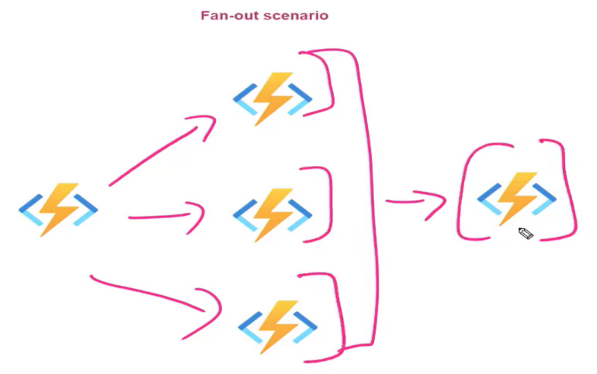

This can be solved by durable function -> we have one orchestration function that responsible for maintaining the workflow -> In Visual Studio we can create durable function project

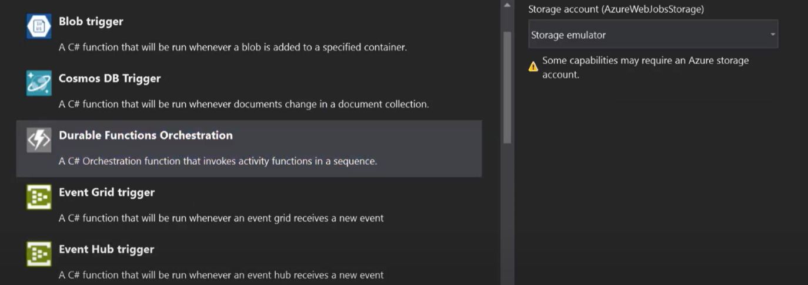

It calls many activity function, that we can set here for sequential operation.

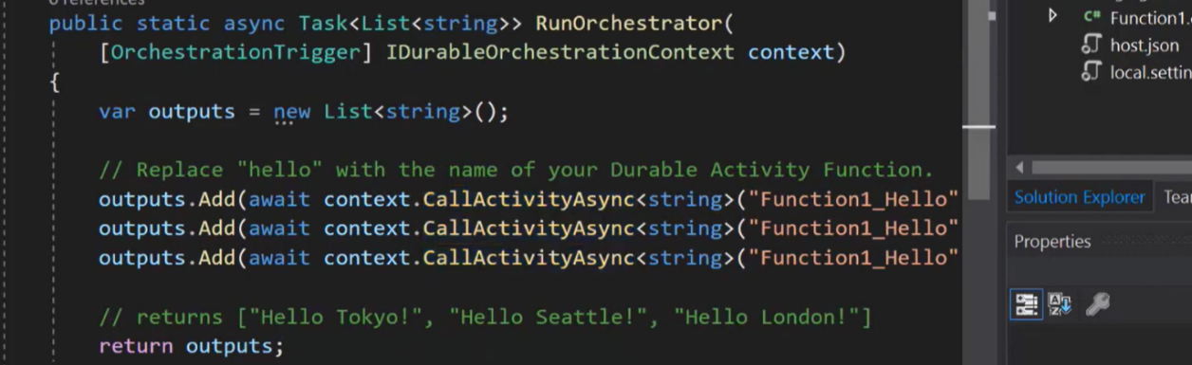

* 1. **Consume Function App into your Web Application:**

Just like API, we can also use Azure function to perforce all those task that a web service or web API do

Below are the line of code need to be write in your Web application to consume Azure function.

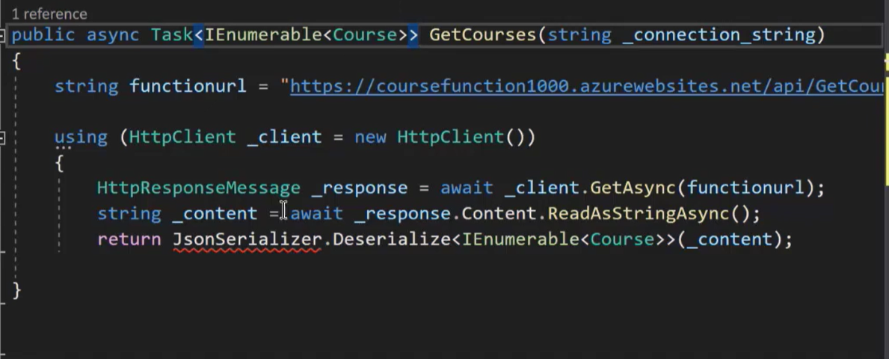

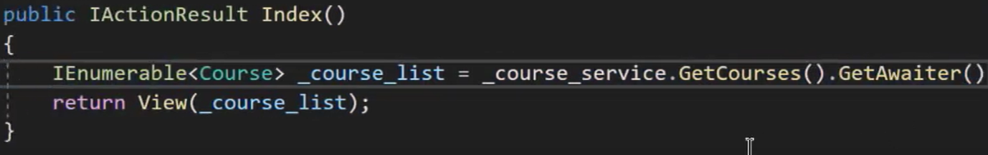

1. **Azure Storage Account**
   1. **Access blob outside the could**

When we upload any file (image, video, text etc) into blob -> it provides a unique url to each file

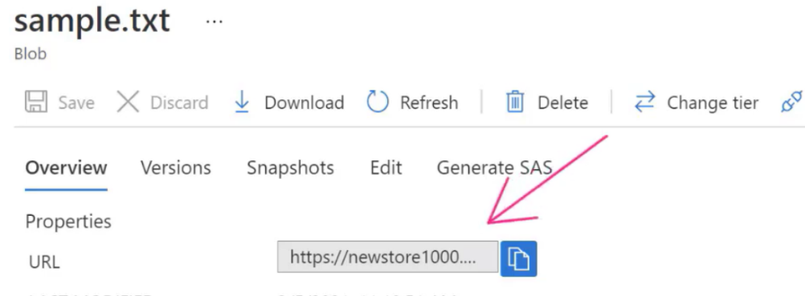

Copy the URL and browse -> it says no specified resource exist - > and the reason is when you login into Azure you have permission to use these file, but from outside, you are anonymous user and need permission to access the file

There are different ways to provide permission

* Change the Access level from Private to public

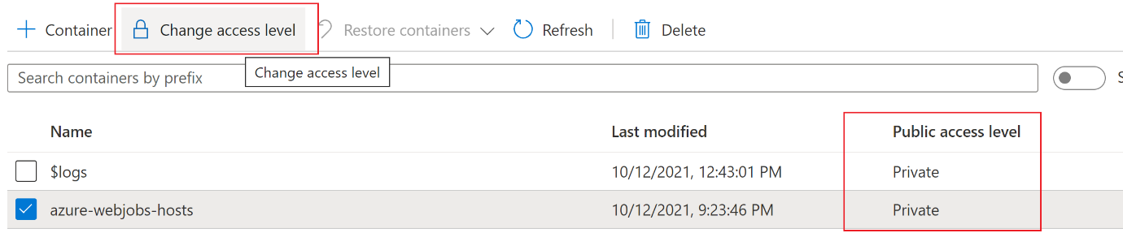

* Other ways to authorise user to access the storage account are



* 1. **Access Keys**

Click on access key in storage account -> copy the keys -> go to Azure Storage Explorer -> Add an Account -> click Storage Account Service -> And add Key -> Save -> Now we can access the storage account into local

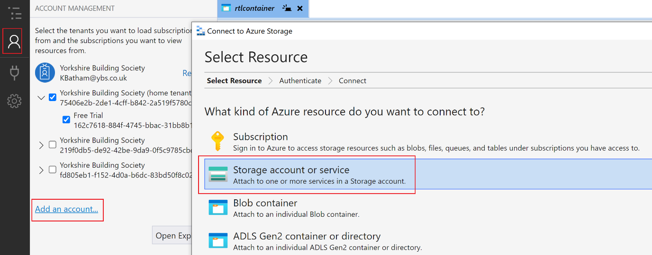

**Note:** access key – applied at the storage account level -> so by access key user complete access on all the services at storage account and can do anything into your storage account.

If want to give limited permission or permission at container level or blob level, or table or queue level -> Choose SAS

* 1. **Shared Access Signature**

SAS key can be applied at Storage Account level as well as Container level or particular blob level

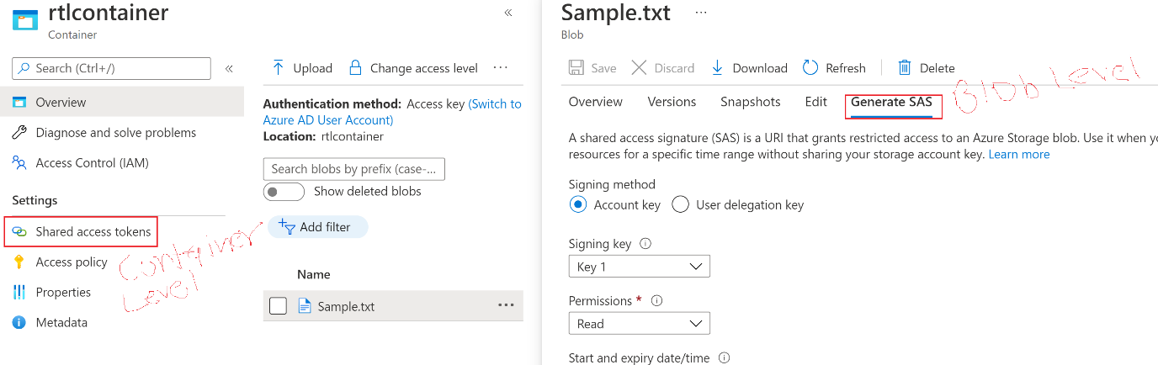

SAS -> At Storage Account level

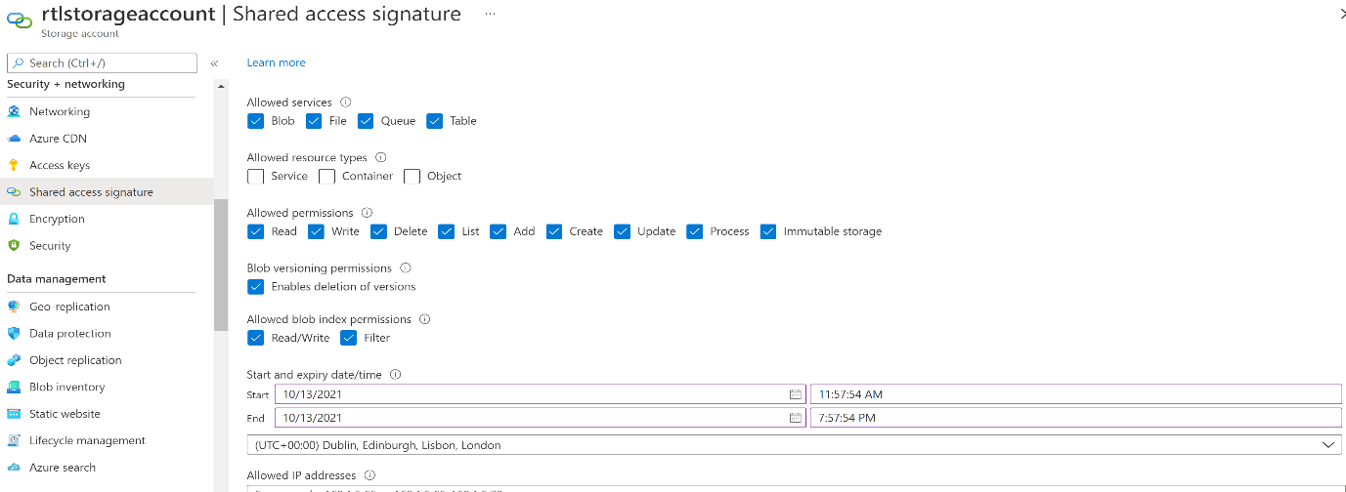

Once SAS created -> we cannot delete or remove it -> either have to wait till the expiry date

Or

We have use the Access Policy to invalidate the SAS

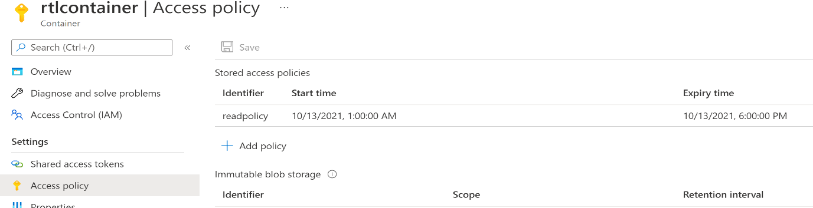

* 1. **Access Control (IAM)**

In your Active Directory -> you have multiple users or you can create new user -> Now you want that user to access your storage account

So, In access Control -> we can add user to access resource -> Assign then role and permission

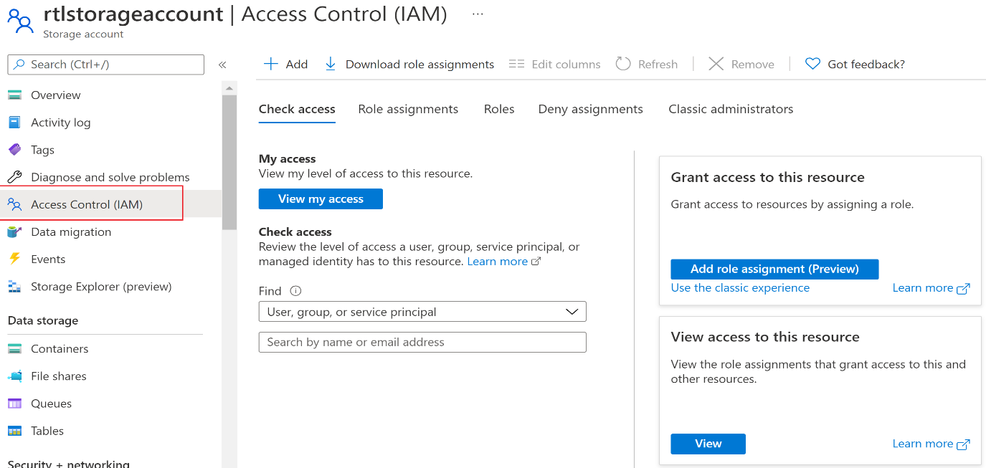

* 1. **Life Cycle Management**

Using this feature -> we can create a rule to move blob to Cool or Achieve tier based on the usage.

For example: rule applied -> if any blob not used or modified from last 30 days then move it to Cool Tier

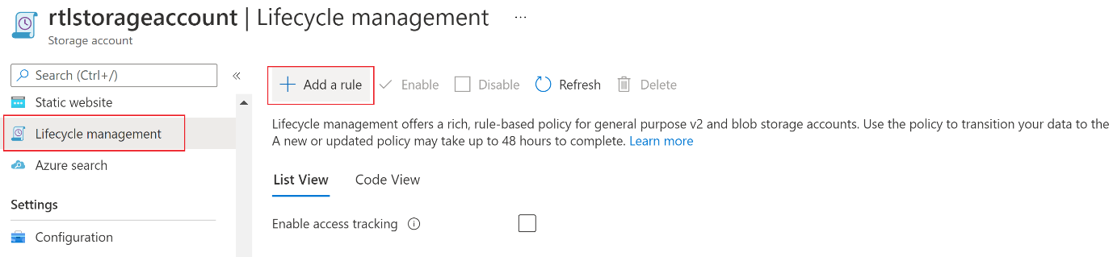

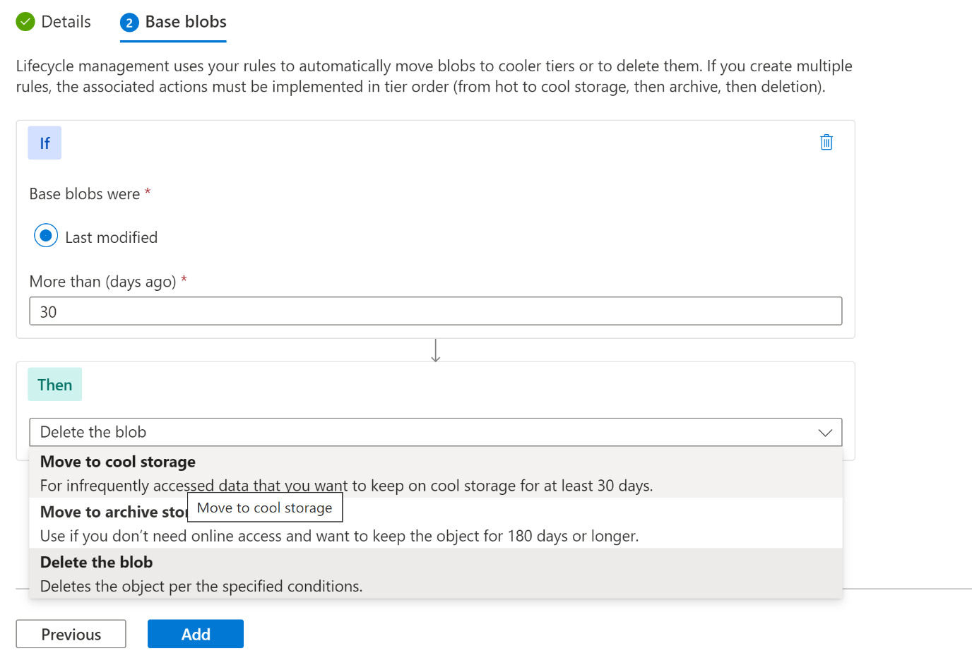

1. **Azure CosmosDB**

* A fully managed NoSQL database
* Fast access to your data
* Completely manages service - underline infrastructure completed manage by Azure
* High availability

Benefits of cosmosdb is you can use the below API to store different type of data

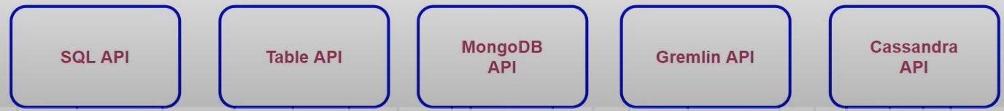

* Docker If you choose SQL API -> then you can save JSON document and can use sql language to query the document
* If choose Table API -> Store data in table like format
* If you want to host Graph based data you can use Gremlin API
* If want to use Cassandra, its also available.

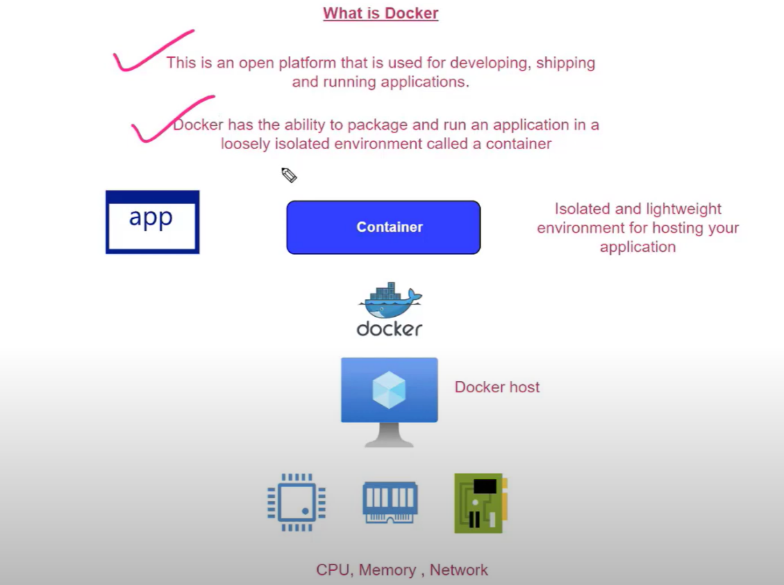

* To deploy your application on VM, we first need to install the Docker runtime
* Docker runtime ensure that container can run into VM and manage how container can use the underlying hardware of VM
* Container – is a runnable instance of your image
* Image – is a read-only template with instruction that are required to create the Docker container (Means it contains the instruction what required software needed to prepare container (like VM), so that application can run) -> and we create container out of that image.
  1. **Install Docker Engine on Linux**

[Install Docker Engine on Ubuntu | Docker Documentation](https://docs.docker.com/engine/install/ubuntu/)

Use below command available on above link – to install docker engine on Linux VM

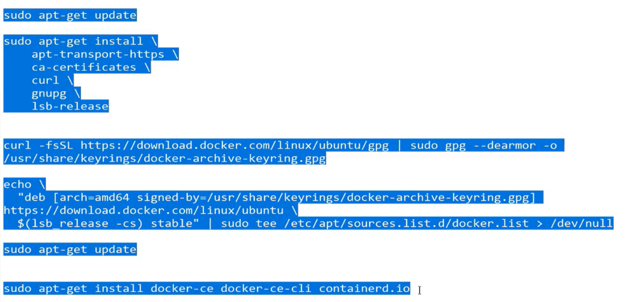

Go to Docker Hub – Download nginx (a web Server) or run the given command

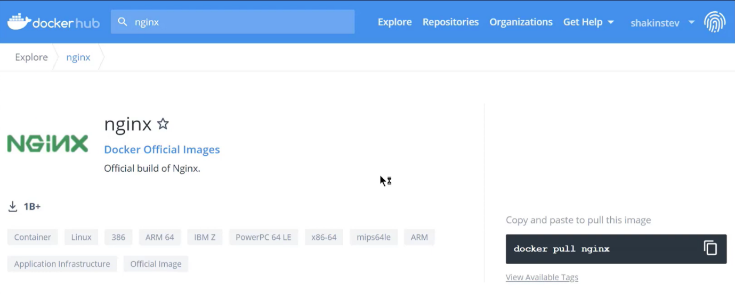

In order to run the container on this Linux VM -> We first have to download the image from the docker hub on this VM -> Then the Docker Runtime take this image and create container out that image -> This is done by Docker Run command

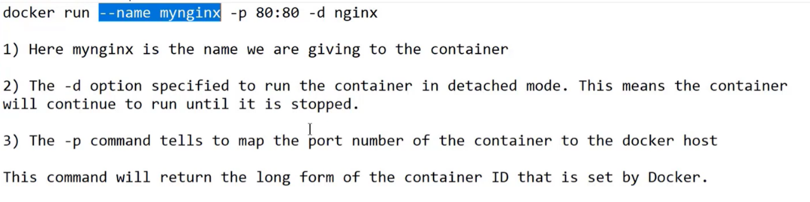

4) Add inbound port (80) to VM -> then browse the public IP

**Note:**

* When a new container created -> It is an isolated unite and everything within the container itself -> Docker creates its own network and created container -> This has nothing to do with public IP of Virtual machine
* Since we use port (80) to map the container, it means nginx running on port 80 by default -> but if you go and try to run the application using public IP of VM -> it will not work -> because docker has assigned a separate network to this container
* **The Solution** – one way is to go and do the port mapping -> Means go ahead and map the port exposed by the container to the port number underlying Docker Host (we did it by -p 80:80, as did above)
* **Important commands** -as below

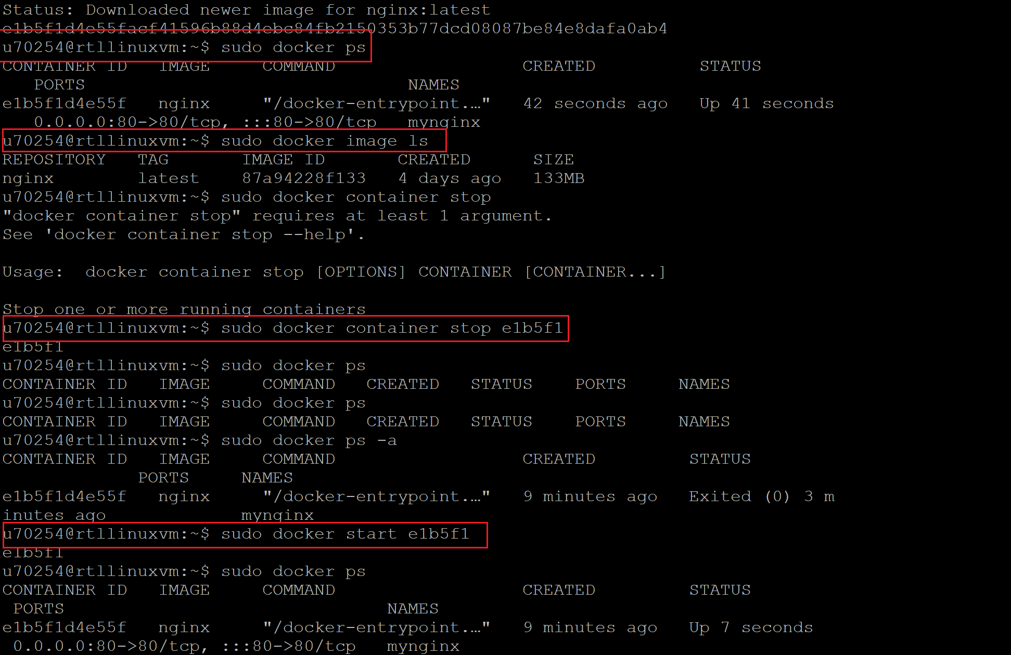

* 1. **Install Docker Engine on Windows**

Docker doesn’t work directly on Windows -> it needs to configure Windows subsystem for Linux

Please Refer - [Manual installation steps for older versions of WSL | Microsoft Docs](https://docs.microsoft.com/en-us/windows/wsl/install-manual)

Alan Video - [AZ-204 - Develop Azure Compute Solutions - Understand the use of docker - YouTube](https://www.youtube.com/watch?v=WgW1HUEKK7M&list=PLLc2nQDXYMHpekgrToMrDpVtFtvmRSqVt&index=12)

**Step 1:** Click on -Turn windows feature on or off -> install below two features.

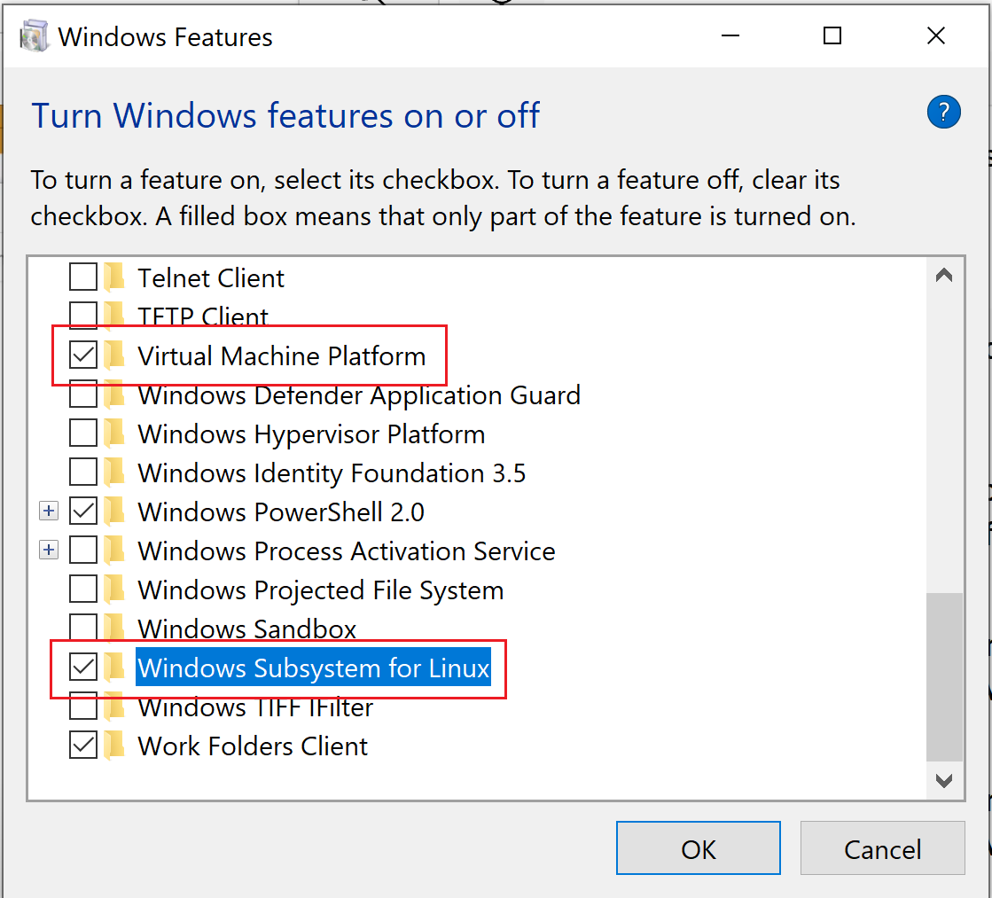

**Step 2:** Follow the step to step points to configure the Docker in Windows (it configured on H30007)

Note: Container on Windows take very large space as compare to linux

**Step 2:** In order to Docker run as windows container -> install the RED highlighted configuration

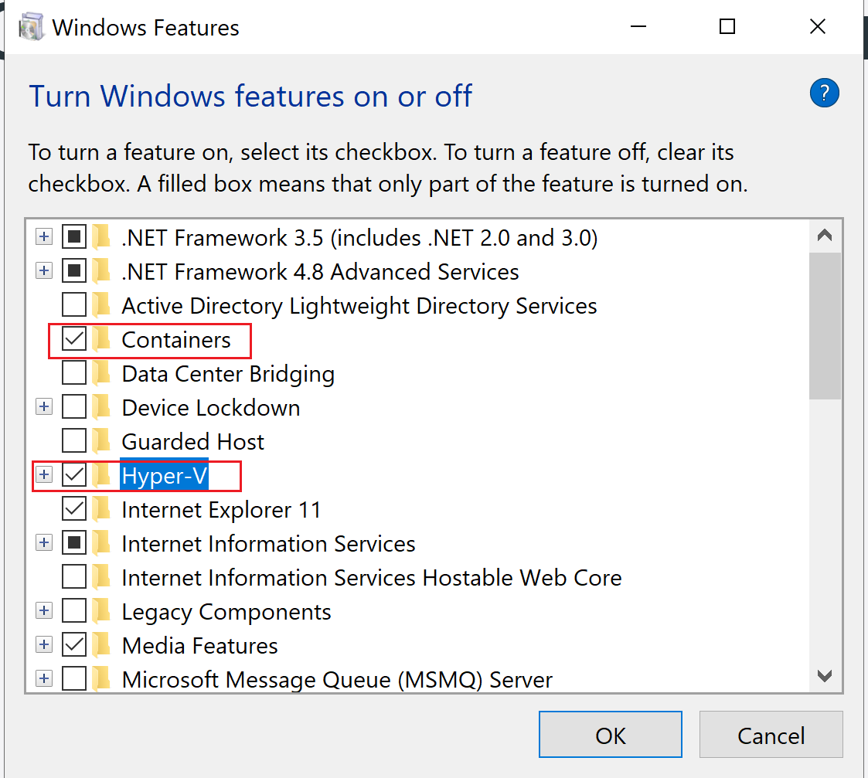

Nginx is only for Linux VM -> in Docker when you switch to windows container -> it will through below error

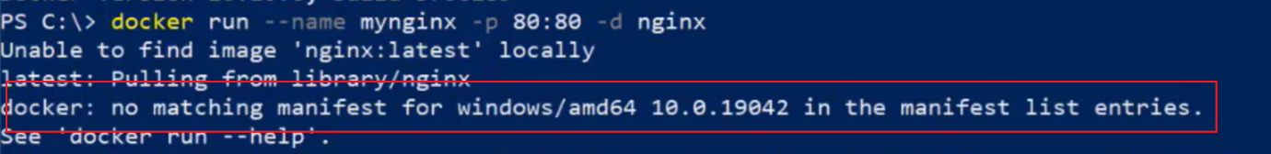

You need to install IIS



Note: Windows based containers are very big in size as compare to Linux based containers

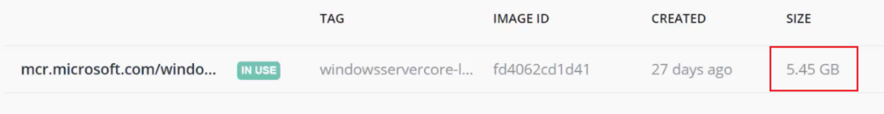

* 1. **Create Image of your application and run as container:**

If you want your application to run into container -> create Docker Support -> It will generate a Docker file and create image and container based on this image.

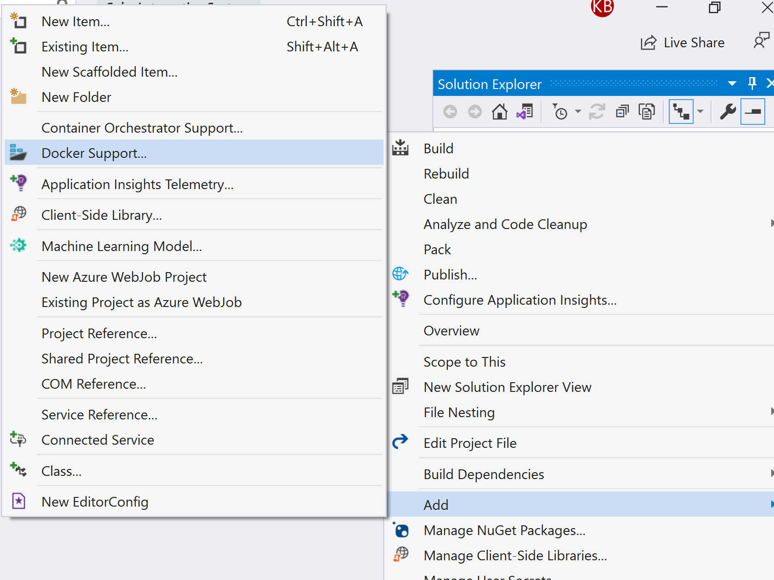

* 1. **Publish the code to Docker Hub:**

In order to deploy the code into Linux VM at azure – We can first publish the image into Docker Hub

* 1. **Deploy the code into Linux VM:**
* Go to your azure Linux VM
* Copy the public IP -> open the Putty and access the VM using VM’s username and Password
* Pull the image into Linux VM (use latest tag) 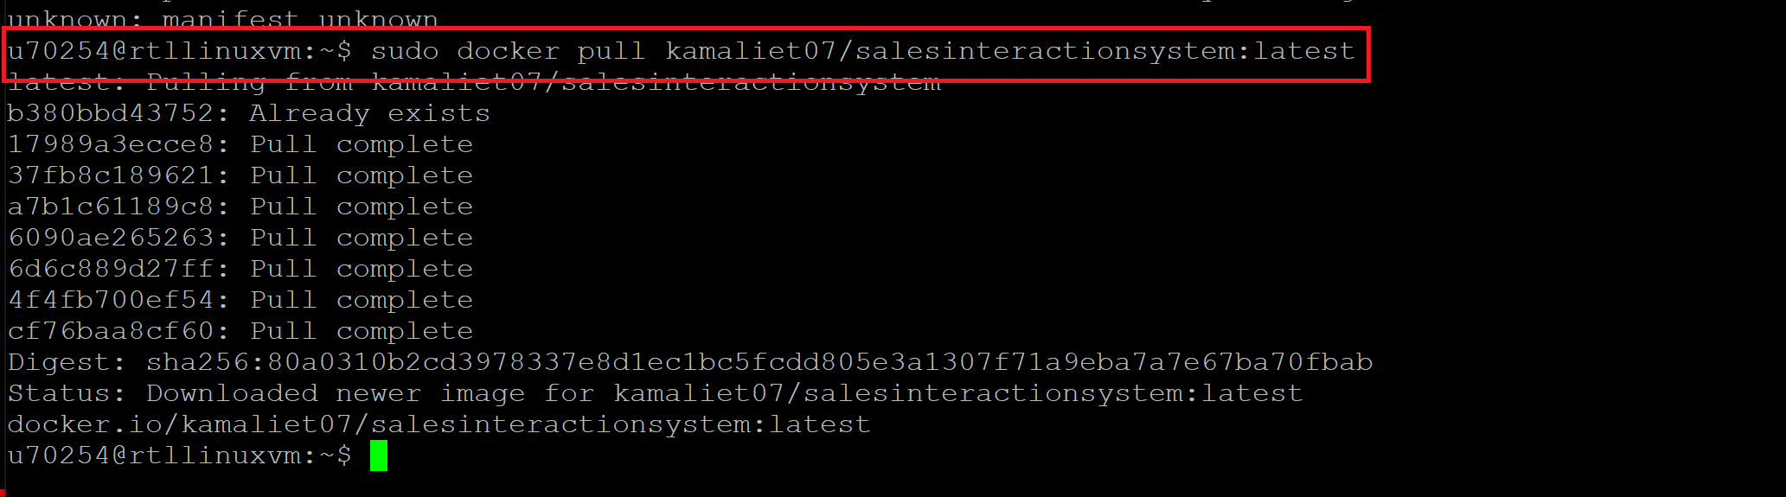
* Now do Docker run

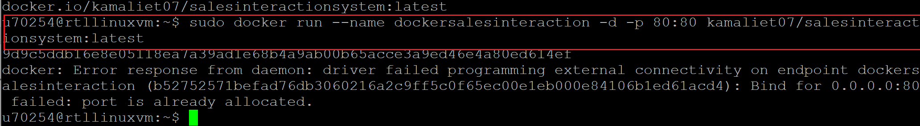

If get error like above -> means port 80 already been used. -> stop the container

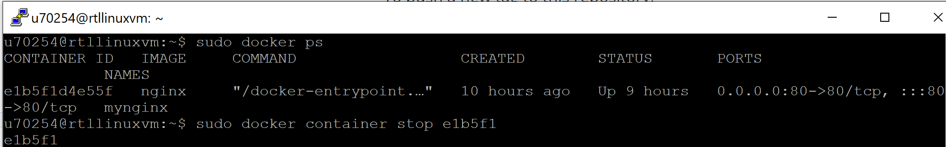

Do docker run again

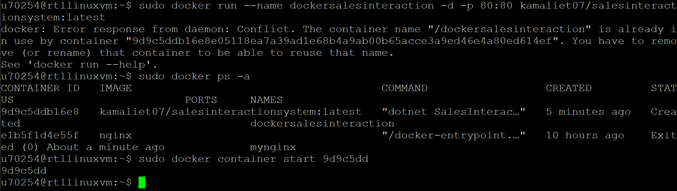

1. **Azure Container Instance:**

Azure container instance offers WebApp kind of service to your image.

* This service provides a fast and simple way to deploy your containers.
* Here you don't need to provision VM's to host your containers
* Containers also get their own fully qualified domain name and IP address.

Create a new resource container instance -> provide the path of image (Docker Hub) – And create

1. **Understand Docker File:**

If we see first three line of docker file -> we can see below line

FROM mcr.microsoft.com/dotnet/aspnet:3.1 AS base

WORKDIR /app

EXPOSE 80

* First line says that build an image based on the image of aspnet 3.1 -> aspnet 3.1 image contains all the required runtime that needed for your application to run on container.
* Second line define the working directory of container

FROM mcr.microsoft.com/dotnet/sdk:3.1 AS build

WORKDIR /src

COPY ["SalesInteractionSystem/SalesInteractionSystem.csproj", "SalesInteractionSystem/"]

COPY ["SIS.BusinessLayer/SIS.BusinessLayer.csproj", "SIS.BusinessLayer/"]

COPY ["SIS.DataAccessLayer/SIS.DataAccessLayer.csproj", "SIS.DataAccessLayer/"]

COPY ["SIS.Utility/SIS.Utility.csproj", "SIS.Utility/"]

COPY ["SIS.Models/SIS.Models.csproj", "SIS.Models/"]

RUN dotnet restore "SalesInteractionSystem/SalesInteractionSystem.csproj"

COPY . .

WORKDIR "/src/SalesInteractionSystem"

RUN dotnet build "SalesInteractionSystem.csproj" -c Release -o /app/build

* Now above line of code says -> copy all your directory to work directory of container

FROM build AS publish

RUN dotnet publish "SalesInteractionSystem.csproj" -c Release -o /app/publish

FROM base AS final

WORKDIR /app

COPY --from=publish /app/publish .

ENTRYPOINT ["dotnet", "SalesInteractionSystem.dll"]

* Above line of code build the application and publish it into workdirectory

1. **Manually push image into Docker Hub:**

Go to your source code repository where docker file also placed -> Run below command manually push the image into docker hub.

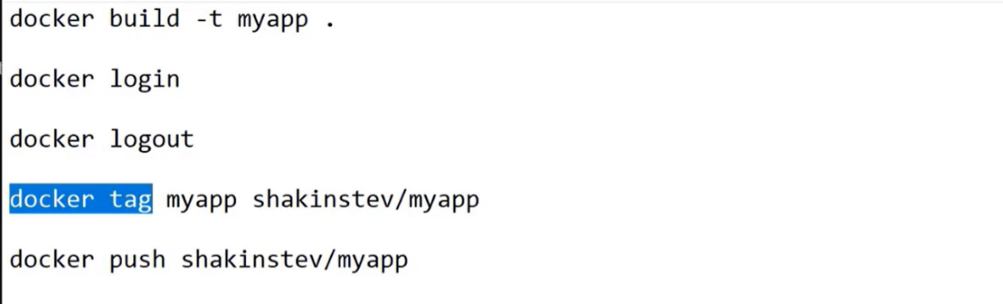

1. **Publishing change to Image:**

You made a change into your application -> now if you want to publish your changed to image into docker hub -> first go and delete previous image

* Docker image rm imagename
* Then run the command ->docker image ls -> to check image has been deleted
* Now tag your latest image -> as highlighted above
* And finally push -> when successfully pushed
* Go to your container instance -> and stop it
* And start gain -> it will pull don the new image and run it

1. **Database Container:**

In order to frontend communicate with backend -you need to create a container for database. The most popular database container is MySql.

**Install MySQL** -> sudo docker run --name=mysql-instance -p 3306:3306 --restart on-failure -d -e MYSQL_ROOT_PASSWORD=India@123 mysql

**Install MySql Client** -> sudo apt-get install mysql-client

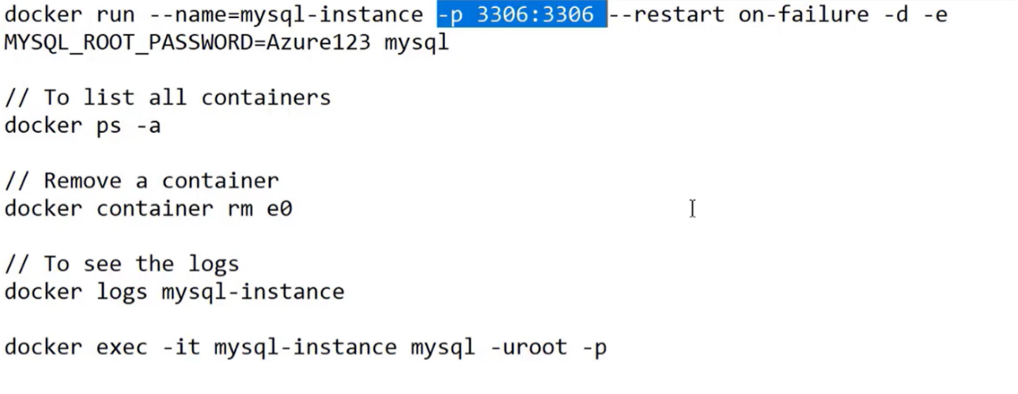

**Note:**

* -d indicates run in background
* -e means set environment variable.

1. **Docker Compose:**

Think about if you have microservices architecture application and you want to manage microservices into docker container -> then deploying microservices and manage then is tedious task

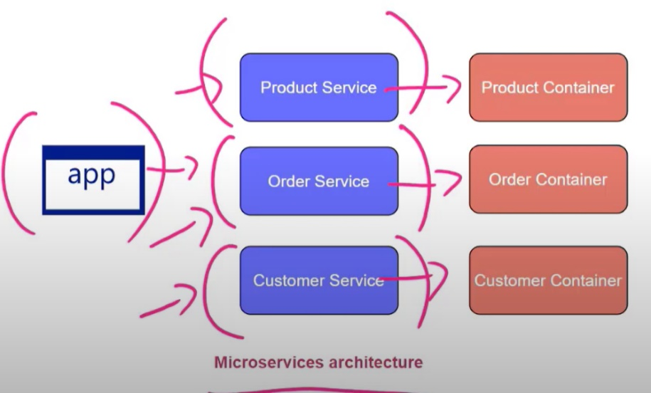

|  |  |
| --- | --- |
| To solve this problem -> we can use docker composed file _> this is deployment mechanism that is available in docker  Here you define a YAML configuration -> |  |

Just Like Terraform -> we can write program to create containers and deploy images.